**ECS**

When to use ECS

* Run Micro services application
* CICD
* Machine learning - Amazon ECS makes it easy to containerize ML models for both training and inference.
* Batch processing - Amazon ECS lets you run batch workloads with managed or custom schedulers on Amazon EC2 On-Demand Instances, Reserved Instances, or Spot Instances
* Applications migration to cloud - Legacy enterprise applications can be containerized and easily migrated to Amazon ECS without requiring code changes

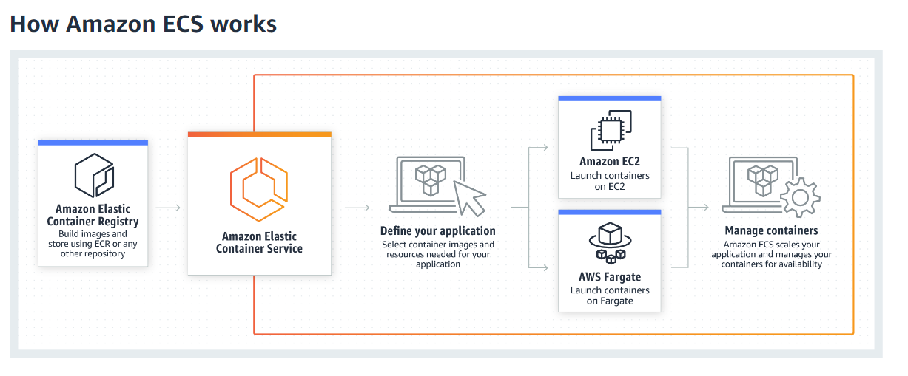

**EKS**

Amazon Elastic Container Service for Kubernetes (Amazon EKS) makes it easy to deploy, manage, and scale containerized applications using [Kubernetes](https://aws.amazon.com/kubernetes/) on AWS

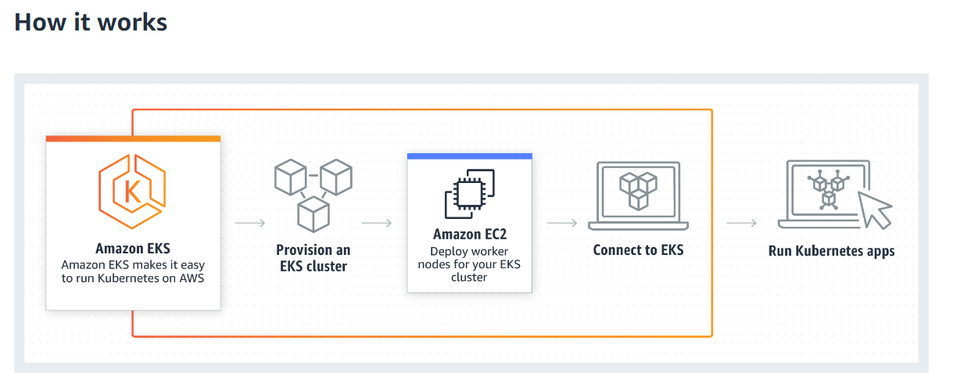

**AWS Fargate**

AWS Fargate is a compute engine for Amazon ECS and EKS* that allows you to run [containers](http://aws.amazon.com/what-are-containers) without having to manage servers or clusters.

ith AWS Fargate, you no longer have to provision, configure, and scale clusters of virtual machines to run containers. This removes the need to choose server types, decide when to scale your clusters, or optimize cluster packing.

AWS Fargate removes the need for you to interact with or think about servers or clusters. Fargate lets you focus on designing and building your applications instead of managing the infrastructure that runs them.

Amazon ECS and EKS have two modes: Fargate launch type and EC2 launch type.

With Fargate launch type, all you have to do is package your application in containers, specify the CPU and memory requirements, define networking and IAM policies, and launch the application.

EC2 launch type allows you to have server-level, more granular control over the infrastructure that runs your container applications. With EC2 launch type, you can use Amazon ECS and EKS to manage a cluster of servers and schedule placement of containers on the servers. Amazon ECS and EKS keeps track of all the CPU, memory and other resources in your cluster, and also finds the best server for a container to run on based on your specified resource requirements. You are responsible for provisioning, patching, and scaling clusters of servers.

EC2 launch type gives you more control of your server clusters and provides a broader range of customization options, which might be required to support some specific applications or possible compliance and government requirements.

Benefits

No cluster to manage

Seamless scaling

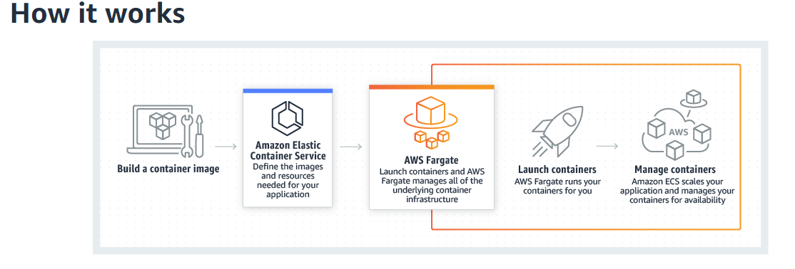

Amazon Elastic Container Service (Amazon ECS) is a highly scalable, fast, container management service that makes it easy to run, stop, and manage Docker containers on a cluster.

You can host your cluster on a serverless infrastructure that is managed by Amazon ECS by launching your services or tasks using the Fargate launch type.

For more control you can host your tasks on a cluster of Amazon Elastic Compute Cloud (Amazon EC2) instances that you manage by using the EC2 launch type.

You can use Amazon ECS to schedule the placement of containers across your cluster based on your resource needs, isolation policies, and availability requirements. Amazon ECS eliminates the need for you to operate your own cluster management and configuration management systems or worry about scaling your management infrastructure.

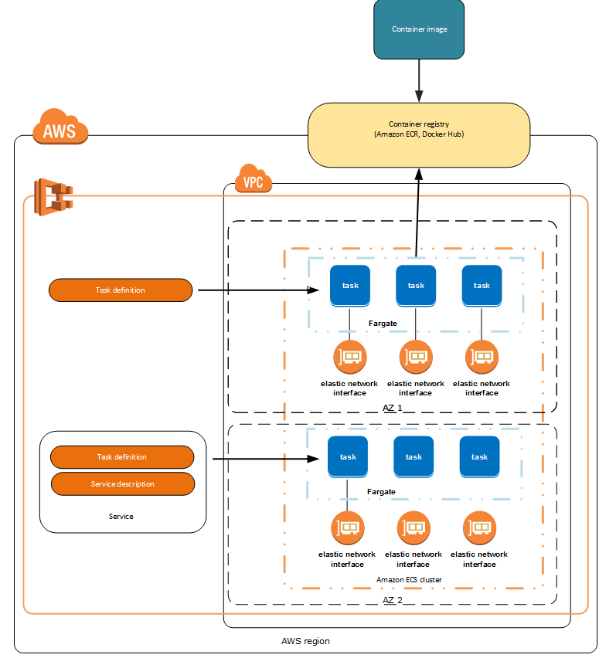

**Task Definitions**

To prepare your application to run on Amazon ECS, you create a *task definition*. The task definition is a text file, in JSON format, that describes one or more containers, up to a maximum of ten, that form your application. It can be thought of as a blueprint for your application

A task definition is required to run Docker containers in Amazon ECS. Some of the parameters you can specify in a task definition include:

* The Docker images to use with the containers in your task
* How much CPU and memory to use with each container
* The launch type to use, which determines the infrastructure on which your tasks are hosted
* Whether containers are linked together in a task
* The Docker networking mode to use for the containers in your task
* (Optional) The ports from the container to map to the host container instance
* Whether the task should continue to run if the container finishes or fails
* The command the container should run when it is started
* (Optional) The environment variables that should be passed to the container when it starts
* Any data volumes that should be used with the containers in the task
* (Optional) The IAM role that your tasks should use for permissions

You can define multiple containers in a task definition

Your entire application stack does not need to exist on a single task definition

Your application can span multiple task definitions by combining related containers into their own task definitions, each representing a single component.

1 application stack  -→ Multiple task definitions (One task – defines one components)

Example:

As an example, imagine an application that consists of the following components:

* A frontend service that displays information on a webpage
* A backend service that provides APIs for the frontend service
* A data store

For DEV everything on one host is OK

For prod – NO

Issues:

* Changes to one component can impact all three components, which may be a larger scope for the change than anticipated
* Each component is more difficult to scale because you have to scale every container proportionally
* Task definitions can only have 10 container definitions and your application stack might require more, either now or in the future
* Every container in a task definition must land on the same container instance, which may limit your instance choices to the largest sizes

create task definitions that group the containers that are used for a common purpose, and separate the different components into multiple task definitions. In this example, three task definitions each specify one container. The example cluster below has three container instances registered with three front-end service containers, two backend service containers, and one data store service container.

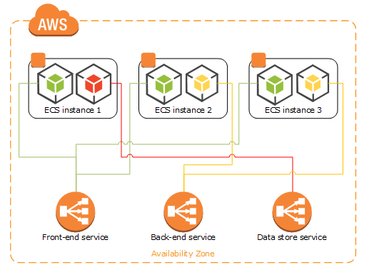

You can group related containers in a task definition, such as linked containers that must be run together. For example, you could add a log streaming container to your front-end service and include that in the same task definition.

### Service Definition Parameters

### Cluster - cluster on which to run your service

### loadBalancers - A load balancer object representing the load balancer to use with your service

### Service Registries - Service discovery uses Amazon Route 53 auto naming API actions to manage DNS entries for your service's tasks, making them discoverable within your VPC

### allows your service to be discoverable via DNS.

### desiredCount - The number of instantiations of the specified task definition to place and keep running on your cluster

role -  IAM role that allows Amazon ECS to make calls to your load balancer on your behalf.

deploymentConfiguration - Optional deployment parameters that control how many tasks run during the deployment and the ordering of stopping and starting tasks.

networkConfiguration

schedulingStrategy

REPLICA—The replica scheduling strategy places and maintains the desired number of tasks across your cluster. By default, the service scheduler spreads tasks across Availability Zones

DAEMON—The daemon scheduling strategy deploys exactly one task on each active container instance that meets all of the task placement constraints that you specify in your cluster

{

    "cluster": "",

    "serviceName": "",

    "taskDefinition": "",

    "loadBalancers": [

        {

            "targetGroupArn": "",

            "loadBalancerName": "",

            "containerName": "",

            "containerPort": 0

        }

    ],

    "serviceRegistries": [

        {

            "registryArn": "",

            "port": 0,

            "containerName": "",

            "containerPort": 0

        }

    ],

    "desiredCount": 0,

    "clientToken": "",

    "launchType": "EC2",

    "platformVersion": "",

    "role": "",

    "deploymentConfiguration": {

        "maximumPercent": 0,

        "minimumHealthyPercent": 0

    },

    "placementConstraints": [

        {

            "type": "memberOf",

            "expression": ""

        }

    ],

    "placementStrategy": [

        {

            "type": "random",

            "field": ""

        }

    ],

    "networkConfiguration": {

        "awsvpcConfiguration": {

            "subnets": [

                ""

            ],

            "securityGroups": [

                ""

            ],

            "assignPublicIp": "ENABLED"

        }

    },

    "healthCheckGracePeriodSeconds": 0,

    "schedulingStrategy": "REPLICA"

}

### Tasks and Scheduling

A task is the instantiation of a task definition within a cluster. After you have created a task definition for your application within Amazon ECS, you can specify the number of tasks that will run on your cluster.

The Amazon ECS task scheduler is responsible for placing tasks within your cluster. There are several different scheduling options available. For example, you can define a service that runs and maintains a specified number of tasks simultaneously

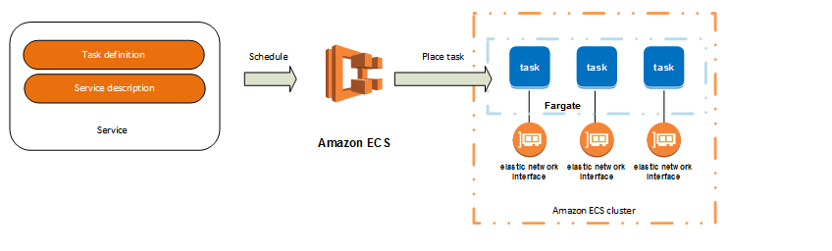

### Clusters

When you run tasks using Amazon ECS, you place them on a cluster, which is a logical grouping of resources. If you use the Fargate launch type with tasks within your cluster, Amazon ECS manages your cluster resources. If you use the EC2 launch type, then your clusters will be a group of container instances you manage. An Amazon ECS container instance is an Amazon EC2 instance that is running the Amazon ECS container agent. Amazon ECS downloads your container images from a registry that you specify, and runs those images within your cluster.

The container agent runs on each infrastructure resource within an Amazon ECS cluster. It sends information about the resource's current running tasks and resource utilization to Amazon ECS, and starts and stops tasks whenever it receives a request from Amazon ECS

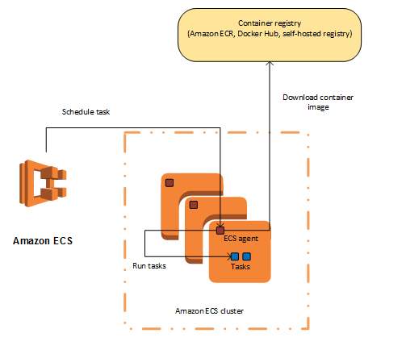

**Service Scheduler**

The service scheduler is ideally suited for long running stateless services and applications. The service scheduler ensures that the scheduling strategy you specify is followed and reschedules tasks when a task fails (for example, if the underlying infrastructure fails for some reason).

There are two service scheduler strategies available:

* REPLICA—The replica scheduling strategy places and maintains the desired number of tasks across your cluster. By default, the service scheduler spreads tasks across Availability Zones. You can use task placement strategies and constraints to customize task placement decisions
* DAEMON—The daemon scheduling strategy deploys exactly one task on each active container instance that meets all of the task placement constraints that you specify in your cluster. When using this strategy, there is no need to specify a desired number of tasks, a task placement strategy, or use Service Auto Scaling policies.

The service scheduler optionally also makes sure that tasks are registered against an Elastic Load Balancing load balancer.

**Manually Running Tasks**

The RunTask action is ideally suited for processes such as batch jobs that perform work and then stop

**Running Tasks on a cron-like Schedule**

If you have tasks to run at set intervals in your cluster, such as a backup operation or a log scan

**Custom Schedulers**

Amazon ECS allows you to create your own schedulers that meet the needs of your business, or to leverage third party schedulers

# Using Data Volumes in Tasks

There are several use cases for using data volumes in Amazon ECS task definitions. Some common examples are to provide persistent data volumes for use with containers, to define an empty, nonpersistent data volume and mount it on multiple containers on the same container instance, and to share defined data volumes at different locations on different containers on the same container instance.

**Support for Windows containers as well**

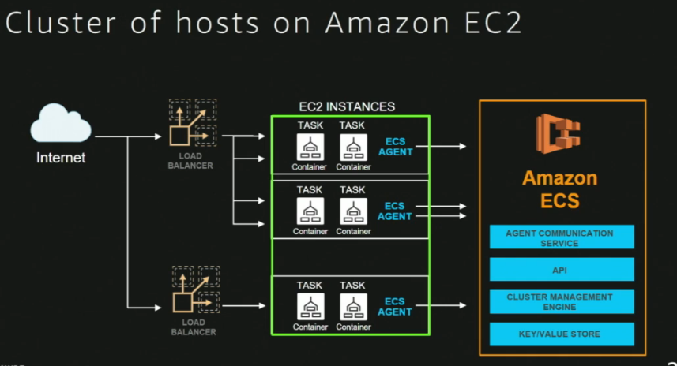

Scheduled jobs.. example run every Friday..

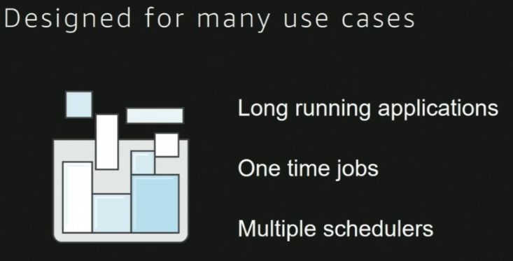

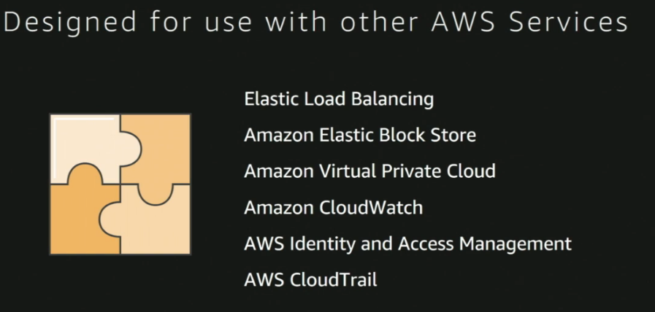

* Deployment – Added in service definition
* Logging – Added in task definition
* Monitoring – using Cloud watch..
* Scaling
  + ECS service – Alert when to add new task

Your Amazon ECS service can optionally be configured to use Auto Scaling to adjust its desired count up or down in response to CloudWatch alarms.

Amazon ECS Service Auto Scaling supports the following types of scaling policies:

* [Target Tracking Scaling Policies](https://docs.aws.amazon.com/AmazonECS/latest/developerguide/service-autoscaling-targettracking.html)—Increase or decrease  the number of tasks that your service runs based on a target value for a specific metric. This is similar to the way that your thermostat maintains the temperature of your home. You select temperature and the thermostat does the rest.
* [Step Scaling Policies](https://docs.aws.amazon.com/AmazonECS/latest/developerguide/service-autoscaling-stepscaling.html)—Increase or decrease the number of tasks that your service runs based on a set of scaling adjustments, known as step adjustments, which vary based on the size of the alarm breach.
  + ECS cluster – Alert when to add another ECS instance..

Yes. As an Amazon EC2 customer, you have root access to the operating system of your container instances, enabling you to take ownership of the operating system’s security settings as well as load and configure additional software components for security capabilities such as monitoring, patch management, log management and host intrusion detection.

#####

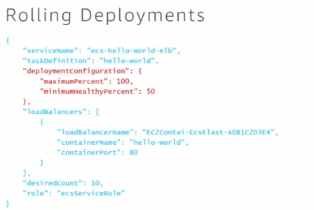

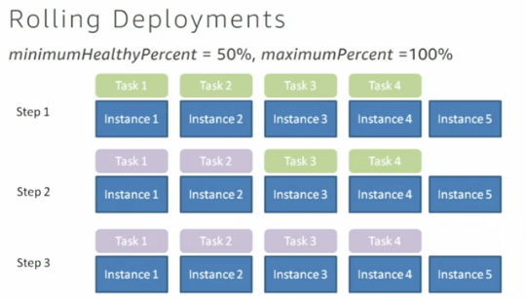

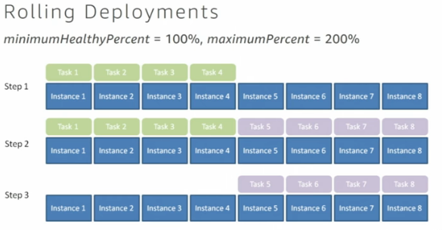

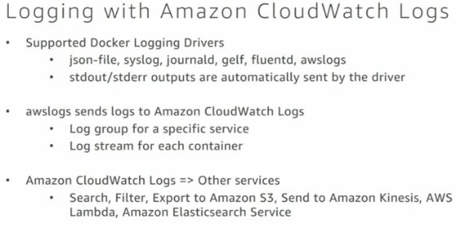

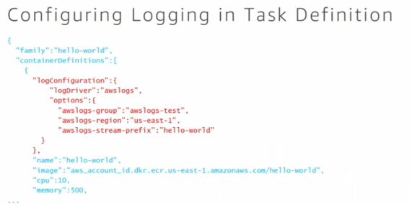

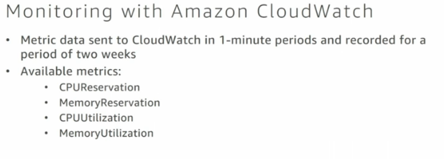

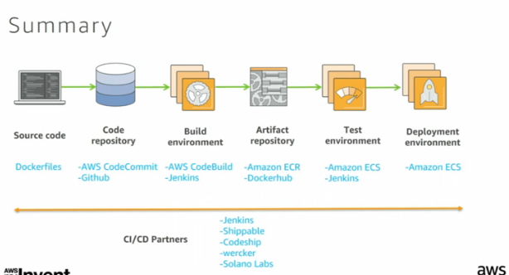

**From:** Shantaram Vernekar <[shantaram_vernekar@persistent.com](mailto:shantaram_vernekar@persistent.com)>   
**Sent:** Saturday, July 28, 2018 5:12 PM  
**To:** Shantaram Vernekar <[shantaram_vernekar@persistent.com](mailto:shantaram_vernekar@persistent.com)>; Vernekar, Shantaram [CCC-OT NE] <[sv16217@imcnam.ssmb.com](mailto:sv16217@imcnam.ssmb.com)>  
**Subject:** AWS - ECS

Questions around 1-4 questions

EC2 container registry (EC2) – Docker Hub

Supports private docker repositories using AWS IAM

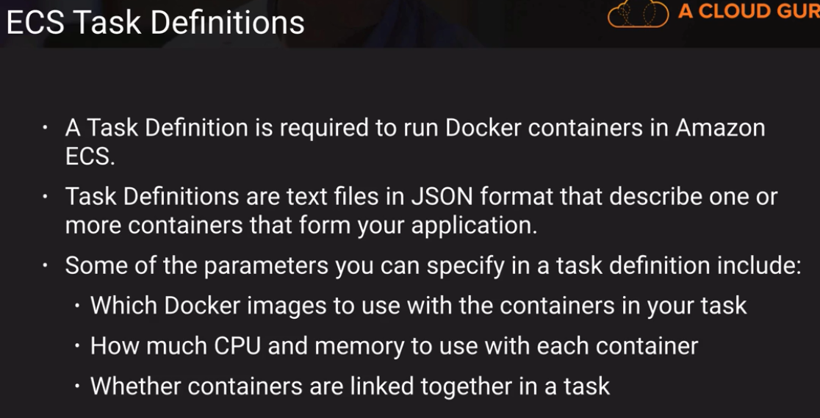

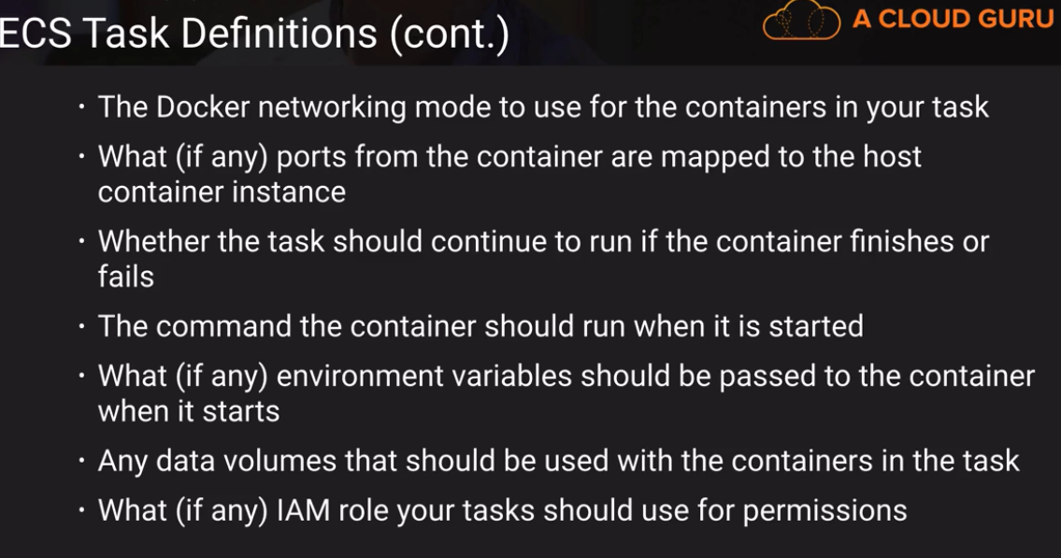

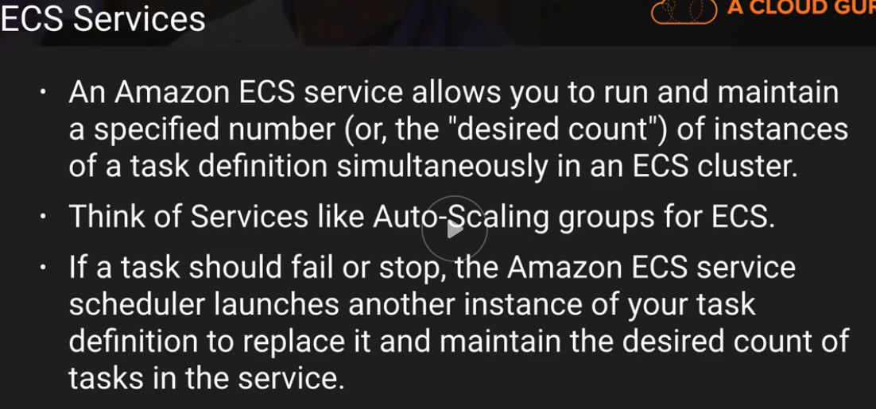

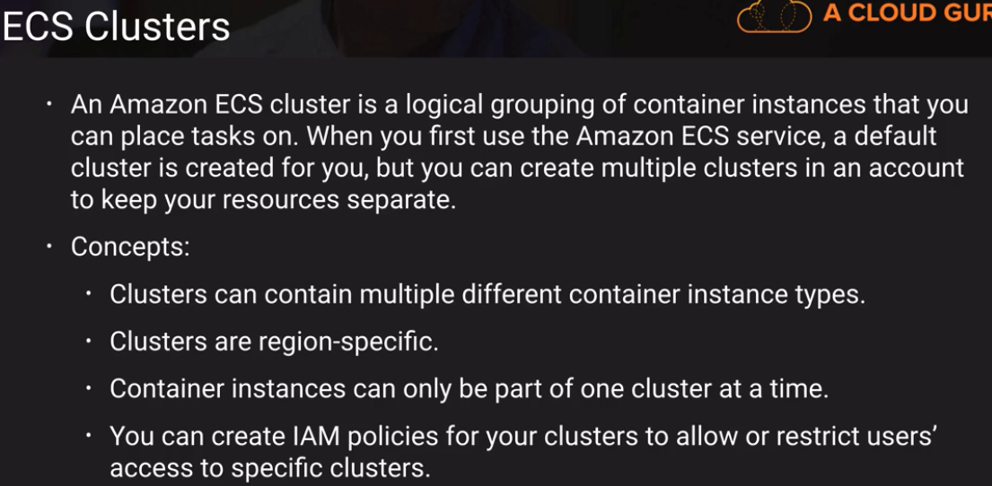

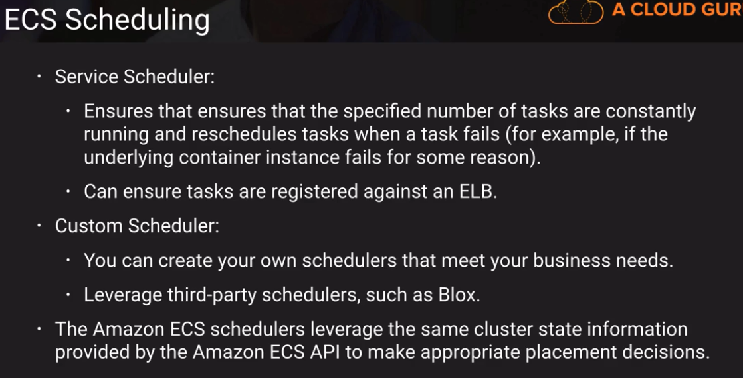

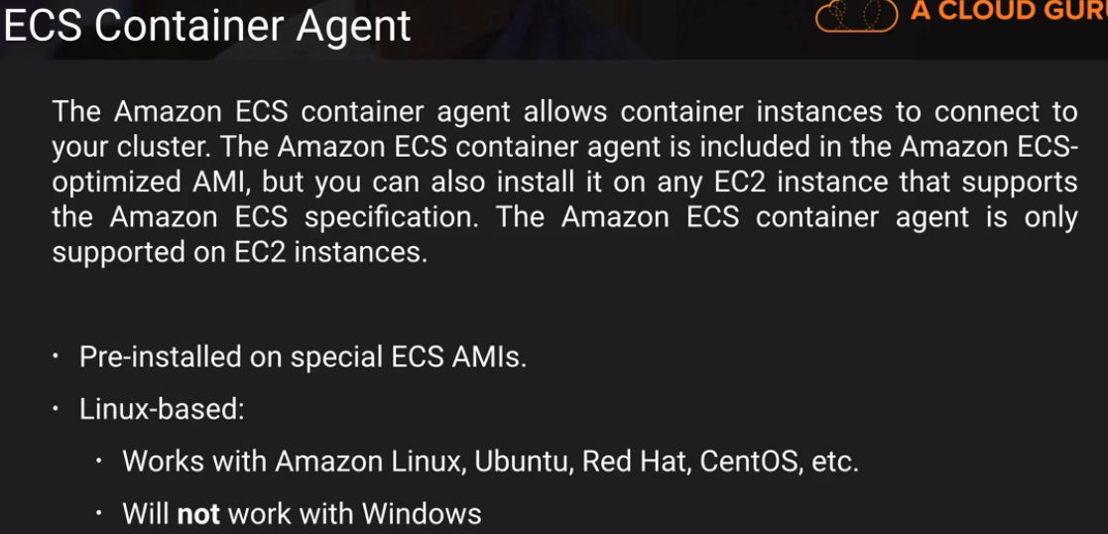

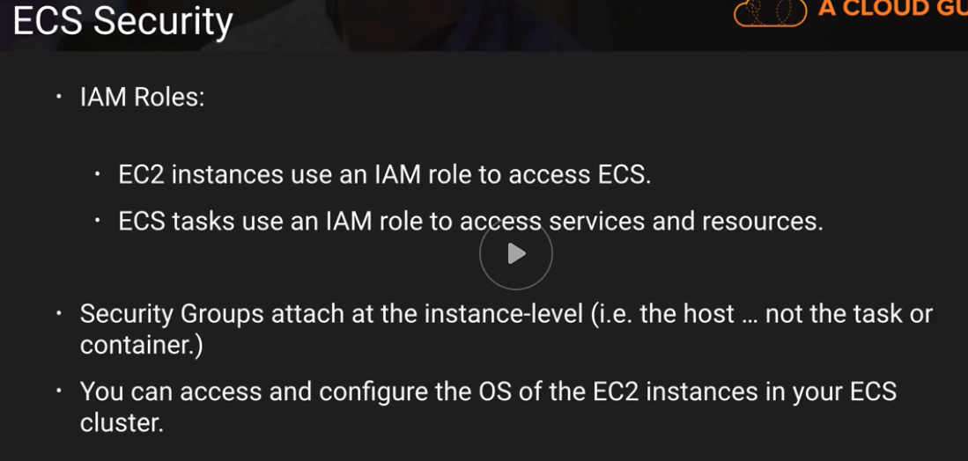

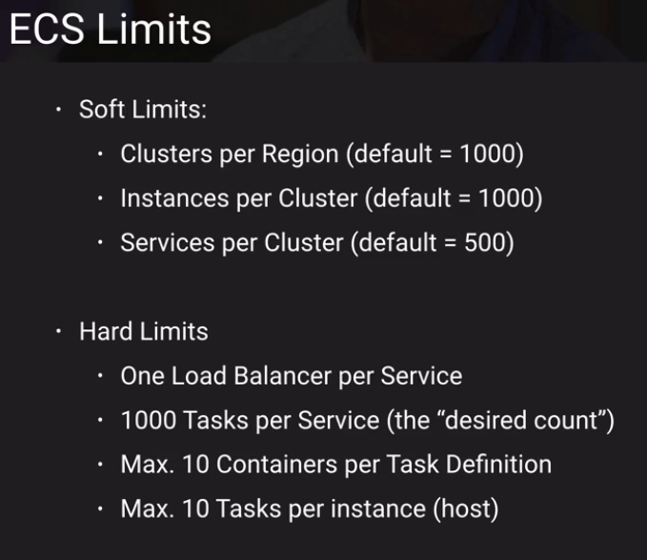

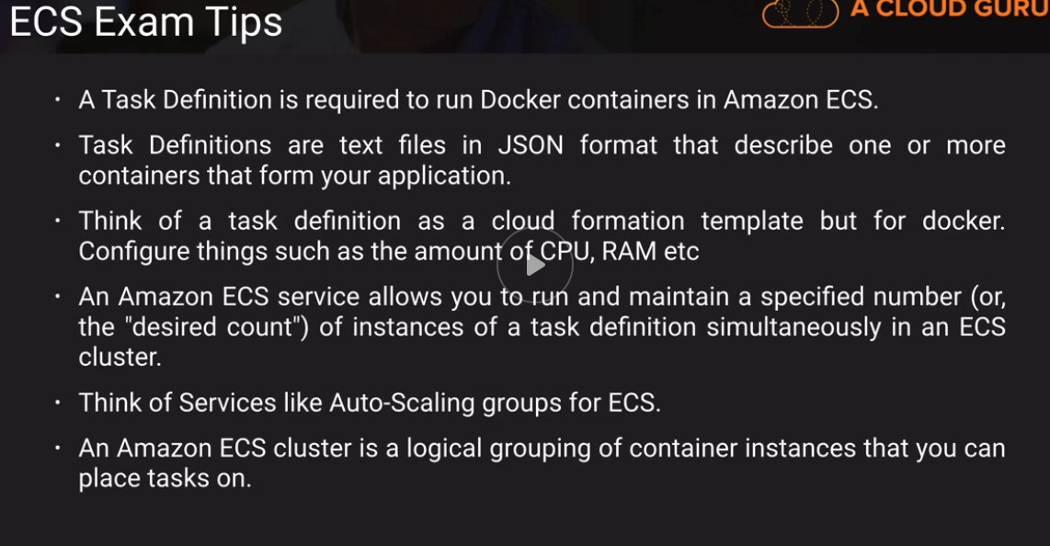

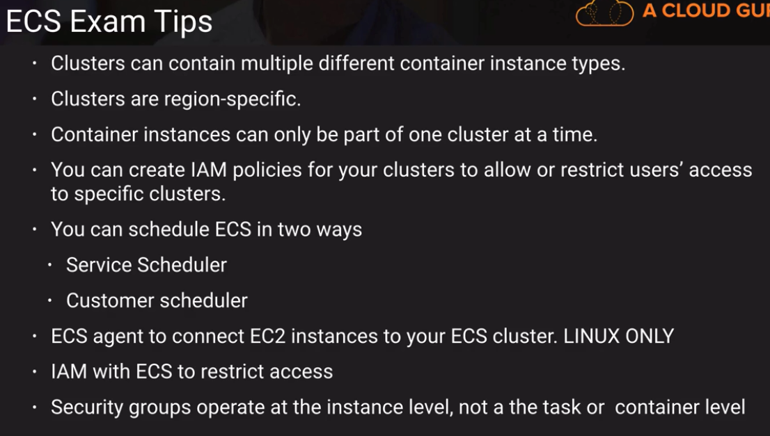



Thanks & Regards,

Shantaram Vernekar

DISCLAIMER  
==========  
This e-mail may contain privileged and confidential information which is the property of Persistent Systems Ltd. It is intended only for the use of the individual or entity to which it is addressed. If you are not the intended recipient, you are not authorized to read, retain, copy, print, distribute or use this message. If you have received this communication in error, please notify the sender and delete all copies of this message. Persistent Systems Ltd. does not accept any liability for virus infected mails.

Questions around 1-4 questions

EC2 container registry (EC2) – Docker Hub

Supports private docker repositories using AWS IAM























Thanks & Regards,

Shantaram Vernekar